## **PUBLISH DATA TO**

# **PYTHON CODE**

|  |  |  |  |
| --- | --- | --- | --- |
| **Team ID** |  | | |
|  | PNT2022TMID03152 |  |
| **Project Name** | Gas Leakage Monitoring & Alerting System for Industries | | |

**Gas Leakage Monitoring & Alerting System for Industries**

**Python code**:

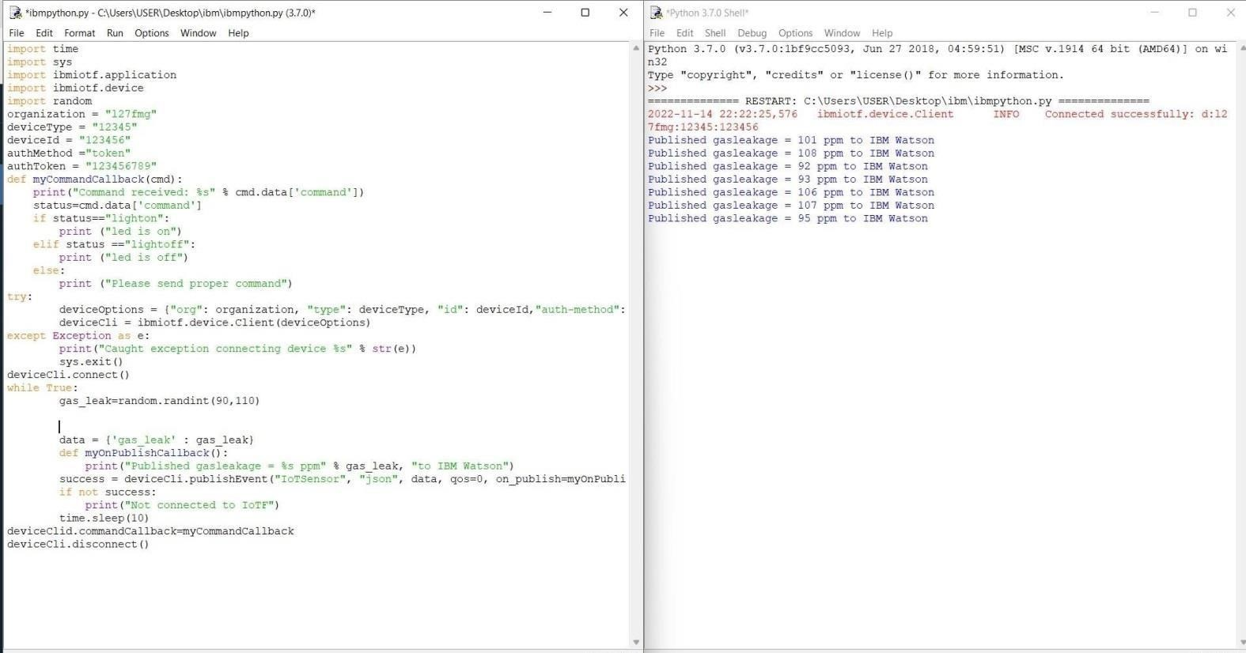

**IOT WATSON CONNECTION:**

